Rear Wing

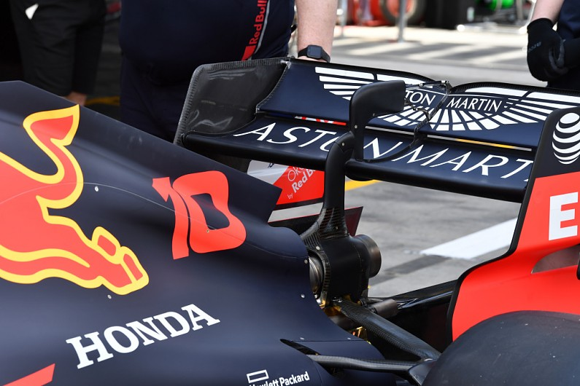

**Aim:**

* To create a rear wing to regulate airflow and deliver optimal downforce to enable higher corner speed of automobiles.

**Mechanism and market use:**

wing is a device whose intended design is to generate downforce as air passes around it, not simply disrupt existing airflow patterns. As such, rather than decreasing drag, automotive wings actually increase drag.

Rear wing in race cars increases downforce tremendously and increases corner speed but it also increases drag and tries to slow down the car in straights.

The basic principle of a formula one wing is exactly the same as with a common aircraft. The greatest difference is the direction air is pressed and how that aerodynamic force is generated. Knowing that an aircraft wing does the opposite of an F1 wing. As air flows over the wing, it is disturbed by the shape, causing a drag force. Although this force is usually less than the lift or downforce, it can seriously limit top speed and causes the engine to use more fuel to get the car through the air.